Change Subscriber Account

Version Control:

Use Case Name: |  | Change Subscriber Account
Use Case Owner: |  | Sumit Borade
Current Version |  | 0.2
Use Case Version History
Modified Date | Version |  | Modified By | Change Description
July 9, 2009 | 0.1 |  | Tom Schnarr | Initial Version
November 30,2009 | 0.2 |  | Prashant Marathe | Updated for the latest information provided by Yousee.

Brief Description:
This use case describes the process by a YouSee subscriber wishes to change account level information that is managed within SMP. The latest information of the subscriber will also be updated in Device history only for the subscribers with Cable broadband services.

Related Documents
- YouSee SMP SOW2Architecture Requirements Document
- YouSee SMP SOW2 Business Requirements Document

Related Use Cases

Pre-Conditions
- Subscriber is an active YouSee subscriber and managed by SMP.

Post-Conditions
- Subscribers updated information is updated in Device History.
- Subscriber is free to use the services they have ordered.

Use Case

Primary Flow Diagram

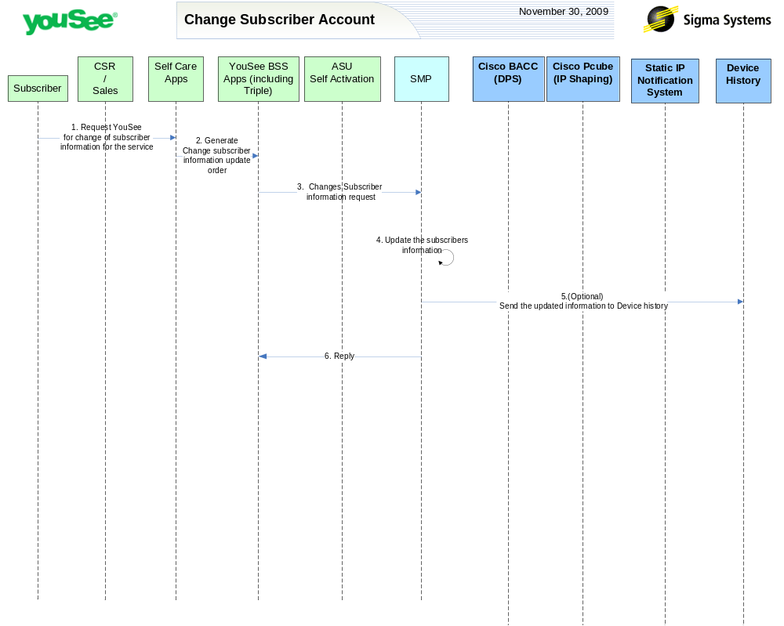

Primary Flow Detail
# | Actor: Key Action | Description | Alternate Flows/Details
 | Subscriber: Contacts YouSee via Self Care portal and orders change in the subscriber details. | Subscribers wants to change or update any of the subscriber details.  Amongst the following information Subscriber can update any or all of the information-  business_phone  business_phone_extension  cell_phone  email  first_name  middleName  last_name  phone  service_provider_id  subscriber_typ
 | Self Care: Order is created in YouSee BSS applications | From the Self Care Portal, the order is created for fulfillment in the YouSee BSS Applications  The BSS components perform a variety of qualification and product catalog decomposition and communicate an order to SMP defining the subscriber, address, candidate CPE and services as ordered by the customer.
 | YouSee BSS: Order is communicated to SMP to change the subscribers information | YouSee BSS (Triple) will communicate the order to SMP through SMP’s Order Management API. Triple will provide the changed information to SMP.
 | Sigma SMP: The Sigma SMP will update the latest information for the given Subscriber | SMP will Update the information on the Subscribers Address.
 | Sigma SMP: (Optional) SMP will create the update order to update the information on Device History. | SMP will send the order to change the given information present on the Device history if the subscriber has the cable broadband services with the updated information.
 | SMP: Replies back to ASU the status of Activation | SMP will reply to ASU the status of Provisioning Order to ASU. | If Provisioning fails then SMP will put the Failed task in Manual Queue.
Note:
- The Device history Updates are only for subscribers with Cable Broadband services.
- The change of Address information is MOVE use case for the Sigma SMP, during the Move use case the subscriber information will be updated as given in the Move use case.
- Apart from the change of address rest details will be updated by using the change subscriber Account use case.

